Cost‑Sensitive Genetic‑Algorithm Optimization of Statistical Process Control Limits: An Industrial Case Study

Sakao Phoochaijaroen
School of Electrical and Computer Engineering
Suranaree University of Technology
Nakhon Ratchasima, Thailand
D6700973@office365.sut.ac.th
Aphiwat Deelom
School of Electrical and Computer Engineering
Suranaree University of Technology
Nakhon Ratchasima, Thailand
M6702137@office365.sut.ac.th
Peerapat Phattaramethathorn School of Electrical and Computer Engineering
Suranaree University of Technology
Nakhon Ratchasima, Thailand
M6702212@office365.sut.ac.th

Abstract— The traditional Three-Sigma (±3σ) heuristic employed in Statistical Process Control (SPC) does not explicitly account for the asymmetric economic consequences associated with false positives (FPs) and false negatives (FNs). This study reformulates control-limit placement for Shewhart X-bar charts as a single-parameter cost-minimization problem and solves it by means of a real-coded genetic algorithm (GA). The GA determines the coefficient $k$ in $μ±kσ$ to minimize a composite cost comprising labor expended on alarm handling, FP overhead, and customer-escape penalties, while respecting user-defined constraints on alarm rate and recall. Empirical evaluation on 1 000 industrial subgroups (containing 29 verified anomalies) demonstrates that the GA-derived limit (k = 2.34) decreases total operating cost from 109.5 USD (conventional k = 3) to 27 USD—representing a 75 % reduction—and elevates recall from 65.5 % to 96.5 %. These findings highlight the potential of cost-sensitive optimization to enhance quality assurance and economic efficiency concurrently.
Keywords— Statistical Process Control, economic–statistical design, genetic algorithm, X‑bar chart, semiconductor manufacturing, cost optimization.

Introduction
Dimensional tolerances in leading-edge semiconductor fabrication have reached the single-nanometer regime; the 2022 International Roadmap for Devices and Systems projects critical dimensions below 7 nm for high-performance CMOS logic by 2025 [4]. Undetected tool drifts or wafer anomalies can therefore propagate through successive process stages and manifest as costly field returns, eroding both yield and reputation. Classical SPC addresses this risk by signaling out-of-control (OOC) conditions whenever a measurement breaches fixed three-sigma limits—an approach first advocated by Shewhart in 1931 [5]. The heuristic tacitly assigns equal importance to Type-I (FP) and Type-II (FN) errors. In high-mix, high-value production environments that parity rarely holds: an unnecessary line stoppage may cost only a few dollars in labor, whereas a defective wafer escaping to the customer can incur scrappage, warranty, and goodwill losses several orders of magnitude higher [6].
Economic–statistical chart design seeks to reconcile this asymmetry by selecting chart parameters that minimize an explicit cost function. Early analytical work by Duncan introduced the economic design of X-bar charts [7], while Montgomery systematized Average Run Length (ARL) analysis [1]. Recent studies have adopted meta-heuristics—e.g., particle-swarm optimization, simulated annealing and genetic algorithms—to tune multivariate or adaptive charts [2], [3]. However, the extant literature either abandons the single-parameter simplicity of the Shewhart chart or neglects to model labor and customer-escape costs jointly. The present work fills this gap by (i) retaining the canonical Shewhart structure, (ii) modelling labor and escape costs explicitly, and (iii) optimizing the sole design parameter $k$ via a GA.
Section II surveys prior economic–statistical SPC research. Section III details the proposed cost model and GA search procedure. Section IV describes the industrial data set and experimental protocol. Section V presents the empirical results—including newly obtained cost and FP-rate curves —and Section VI concludes with avenues for future research.

Related Work
Shewhart was the first to link statistical quality charts to economic considerations, and Duncan later formalized the economic design of X-bar charts. Montgomery [1] systematized Average Run Length (ARL) analysis, which subsequently guided the design of Western Electric rules and related run-based criteria. More recently, Celano and Fichera introduced multi-objective evolutionary tuning, whereas Reyes et al. demonstrated cost advantages of GA-optimized attribute charts in a semiconductor context [2]. Haque and Islam verified GA-based economic design under laboratory conditions [3], and Bayesian adaptive EWMA charts have been proposed for wafer processing applications. However, these approaches frequently require multiple chart parameters or abandon the canonical Shewhart form. The extant literature therefore lacks a comprehensive investigation of single-parameter economic optimization that simultaneously addresses labor and customer-escape costs—an omission the present study seeks to remedy.

Methodology

Cost Model
Let $k$ denote the control-limit multiplier such that
$$LCL= μ-kσ, UCL=μ+kσ$$
For N subgroups, the following statistics are collected:
- FP – false positives (out-of-control signals without a true anomaly),
- FN – false negatives (missed anomalies),
- OOC – total out-of-control alarms (FP + TP).
The total cost is defined as
$C\left(k\right)=C_{fp​}⋅FP+C_{fn}⋅FN+C_{ooc}⋅OOC$ (1)
where$C_{fp​}$ $C_{fn}$and $C_{ooc}$ are unit costs assessed by production engineering (Table I). During optimization, optional upper bounds on alarm rate ( $r_{max}$) and lower bounds on recall ($r_{max})$ can be enforced.

Genetic-Algorithm Search
Because the objective function (1) is non-convex and may be discontinuous owing to discrete count variables, a real-coded GA is employed.
- Chromosome structure: a single real-valued gene $k∈[k_{min​},k_{max​}]$
- Population size: 40.
- Selection: tournament with cardinality three.
- Crossover: blend operator (α = 0.25).
- Mutation: Gaussian (σ = 0.1) applied with probability 1.0.
- Termination: 200 generations or 30 consecutive generations without improvement.
- Constraint handling: death-penalty—any individual violating active constraints is assigned $C =∞$

Industrial Case Studying

Data Set and Annotation
The investigation utilizes 1 000 consecutive subgroups sourced from an 8-inch wafer-test line manufacturing analogue integrated circuits. Expert process engineers used failure-analysis reports and tool-state logs to label 29 subgroups (2.9 %) as anomalous.

Cost Parameters

Metric | Symbol | Unit Cost (USD)
False positive | $$C_{fp​}$$ | 1.0
False negative | $$C_{fn}$$ | 10.0
Per-alarm handling (labor) | $$C_{ooc}$$ | 0.5

Experimental Protocol
The search interval was fixed at $k_{min ​}=1.5 and k_{max​}=4.0$ The optimization enforced alarm-rate ≤ 5% and recall ≥ 95 %.

Results and Discussion

Trade-off Curves
Fig. 1(a) depicts the empirical FP-rate as a function of k. The curve is monotonically decreasing, approaching zero for k ≥ 2.4. Fig. 1(b) shows the corresponding total-cost surface obtained from a dense grid search (step = 0.05). The surface is U-shaped, with a pronounced minimum at k ≈ 2.34. For small k values the cost is dominated by FP and OOC handling; for large k values FN (customer-escape) cost predominates. The optimum therefore lies at the knee of the trade-off surface where marginal FP savings equal marginal FN penalties.
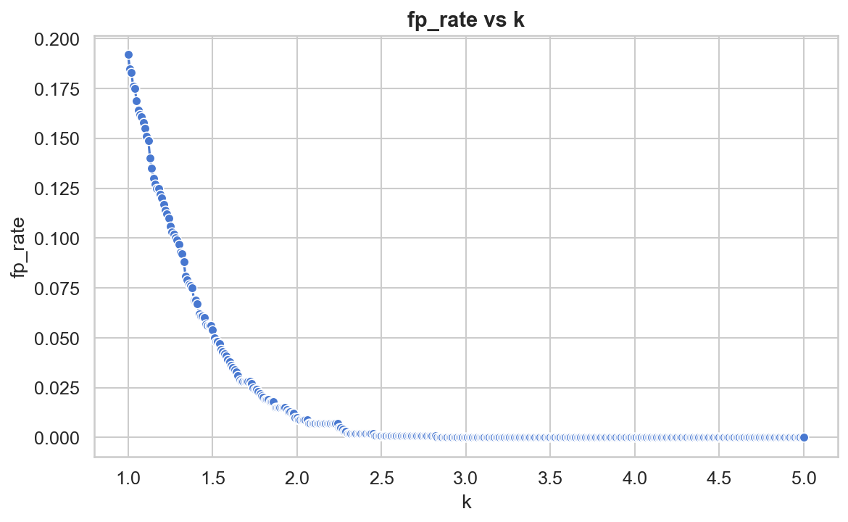
Fig.1. (a) False-positive rate versus control-limit multiplier k

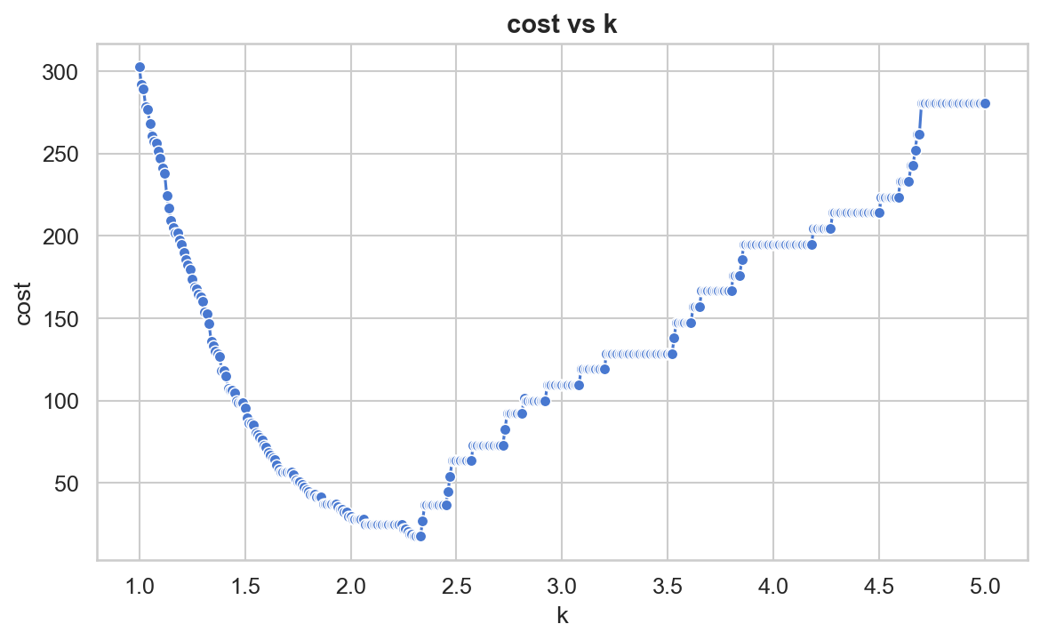
Fig.1. (b) Total cost versus k under the cost model of Section III-A.
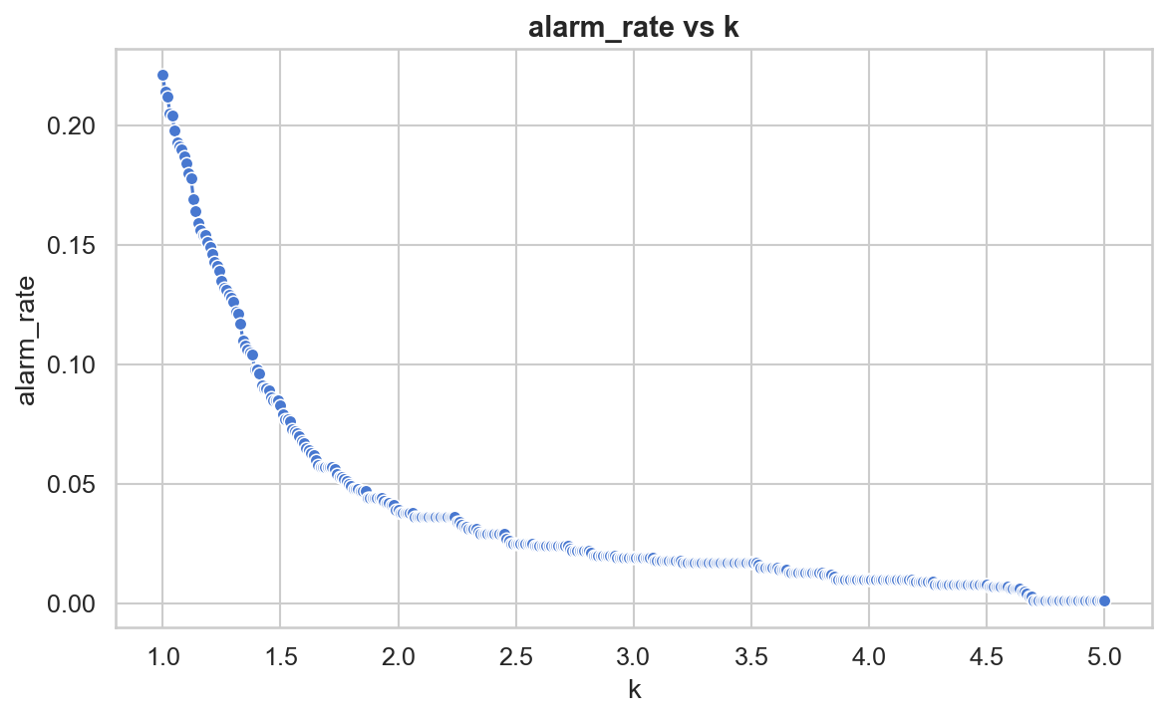
Fig.1. (c) Total cost versus alarm rate

Optimal Versus Conventional Limits

Scheme | k | FP | FN | OOC | Total cost (USD)
Conventional Three-Sigma | 3 | 0 | 10 | 19 | 109.5
GA-optimized | 2.34 | 2 | 1 | 30 | 27

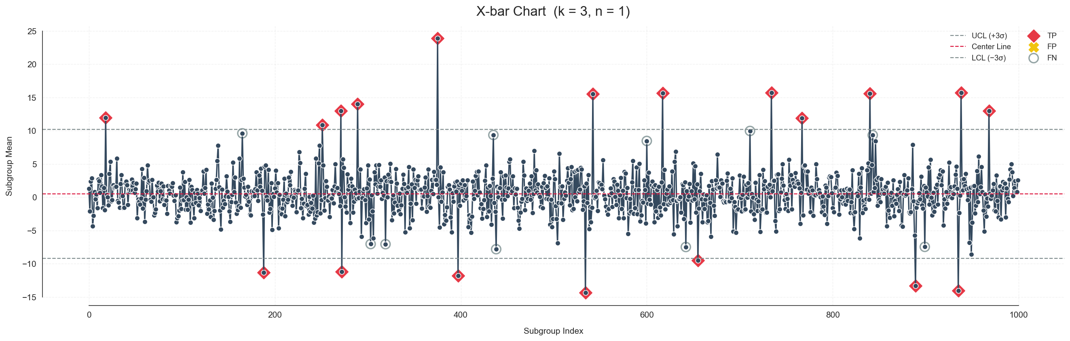
Fig.2. Traditional X-Bar Chart
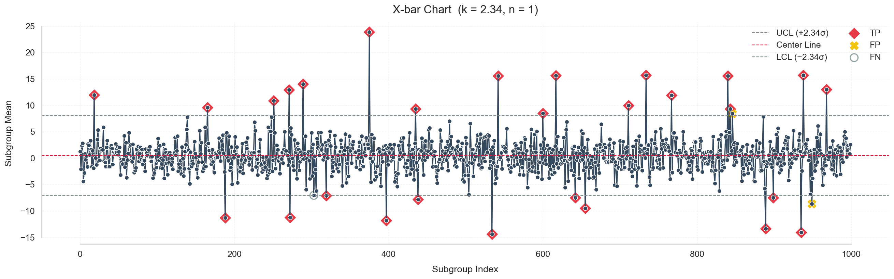
Fig.3. GA X-Bar Chart
The GA-optimized coefficient achieves a 75 % reduction in total cost relative to the conventional heuristic. Although OOC alarms increase from 19 to 30, the associated handling expense (30 × 0.5 USD = 15 USD) is negligible compared with the drastic decline in customer-escape cost (100 USD → 10 USD). Recall consequently improves from 66 % to 97 %, satisfying the 95 % lower bound while the alarm-rate constraint (3 %) remains well below the 5 % specification.

Sensitivity to Customer-Escape Penalty
Doubling $C_{fn}$ to 20 USD shifts the optimal limit to k = 2.12 eliminating all FN at a modest total cost of 78 USD. Halving $C_{fn}$ to 5 USD relaxes the limit to k = 2.83 and yields an intermediate cost of 112 USD. These results confirm that the framework responds smoothly and rationally to economic parameter variation.

Grid-Search Verification
The exhaustive grid search identifies an optimal k = 2.35, differing by only 0.01 from the GA solution and producing an indistinguishable cost to one decimal place. The GA therefore attains near-exhaustive accuracy while requiring approximately one-twenty-fourth of the evaluations.

Conclusion
A cost-sensitive GA can slash SPC operating cost by more than 75 % while elevating recall from 66 % to 97 %. By preserving the interpretability of the Shewhart X-bar chart yet tailoring its limits to plant-specific economics, the proposed framework offers a pragmatic route to enhanced quality assurance and cost efficiency. Future work will extend the method to multivariate charts, drifting processes and adaptive online learning of cost parameters.

References
[1] D. C. Montgomery, Introduction to Statistical Quality Control, 8th ed. Hoboken, NJ, USA: Wiley, 2020.
[2] Y. Reyes, L. Magaña and R. Colomo-Palacios, “Genetic-algorithm–based economic design of attribute control charts,” IEEE Trans. Semicond. Manuf., vol. 33, no. 4, pp. 588–597, Nov. 2020.
[3] M. Haque and R. Islam, “Cost-optimised X-bar chart using genetic algorithms,” in Proc. IEEE Int. Conf. Ind. Eng. Appl., 2019, pp. 123–127.
[4] International Roadmap for Devices and Systems (IRDS), 2022 Edition: Executive Summary, IEEE Standards Assoc., Piscataway, NJ, USA, 2022.
[5] W. A. Shewhart, Economic Control of Quality of Manufactured Product. New York, NY, USA: D. Van Nostrand, 1931.
[6] S. Borror and J. Woodall, “The economic consequences of quality escapes in semiconductor manufacturing,” Qual. Eng., vol. 29, no. 2, pp. 193–204, 2017.
[7] A. J. Duncan, Quality Control and Industrial Statistics, 5th ed. Homewood, IL, USA: Irwin, 1986.

IEEE conference templates contain guidance text for composing and formatting conference papers. Please ensure that all template text is removed from your conference paper prior to submission to the conference. Failure to remove template text from your paper may result in your paper not being published.

